Puzzle - Collision Sensor 碰撞传感器

产品简介
Puzzle - Collision Sensor可以检测碰撞和振动，当检测到时会输出一个脉冲信号。为了使输出信号更稳定准确，我们增加了电路去过滤噪音，因此正常的振动不会促发信号输出。

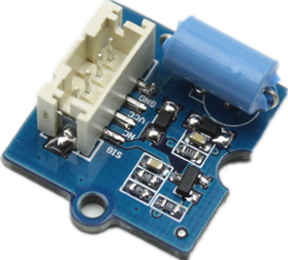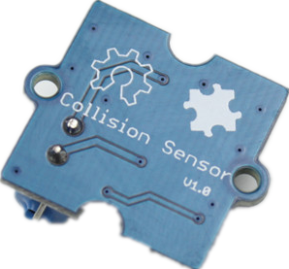
参数规格
电压: 5V

应用示例
这个示例我们用碰撞传感器来检测振动，进而点亮LED，即当振动时LED点亮。将碰撞传感器连接至数字口D2，将LED连接至数字口D13；

/****************************************************************************/
// Function: Monitor if there is any collision
// Hardware: Puzzle - Collision Sensor
// Arduino IDE: Arduino-1.0
//
// This library is free software; you can redistribute it and/or
// modify it under the terms of the GNU Lesser General Public
// License as published by the Free Software Foundation; either
// version 2.1 of the License, or (at your option) any later version.
//
// This library is distributed in the hope that it will be useful,
// but WITHOUT ANY WARRANTY; without even the implied warranty of
// MERCHANTABILITY or FITNESS FOR A PARTICULAR PURPOSE. See the GNU
// Lesser General Public License for more details.
//
// You should have received a copy of the GNU Lesser General Public
// License along with this library; if not, write to the Free Software
// Foundation, Inc., 51 Franklin St, Fifth Floor, Boston, MA 02110-1301 USA
//
/*******************************************************************************/

#define LED 13 //the onboard LED of Arduino or duinofun
#define COLLISION_SENSOR 2//collision sensor is connected with D2 of Arduino
void setup()
{
pins_init();
}

void loop()
{
if(isTriggered())
{
turnOnLED();
delay(2000);
}
else turnOffLED();
}
void pins_init()
{
pinMode(LED,OUTPUT);
turnOffLED();
pinMode(COLLISION_SENSOR,INPUT);
}
boolean isTriggered()
{
if(digitalRead(COLLISION_SENSOR))
{
delay(50);
if(digitalRead(COLLISION_SENSOR))
return true;//the collision sensor triggers
}
return false;
}
void turnOnLED()
{
digitalWrite(LED,HIGH);//the LED is on
}
void turnOffLED()
{
digitalWrite(LED,LOW);//the LED is off
}

我们可以通过代码中的delay(50)来调整传感器灵敏度。
if(digitalRead(COLLISION_SENSOR))
{
delay(50); //change the delay time to adjust sensitiity. The smaller the value,the higher the sensitivity.
if(digitalRead(COLLISION_SENSOR))
return true;//the collision sensor triggers
}
return false;

参考资料
File:Puzzle - Collision Sensor eagle file.zip(超链接)

